**DAILY ONLINE ACTIVITIES SUMMARY**

|  |  |  |  |  |  |  |  |  |
| --- | --- | --- | --- | --- | --- | --- | --- | --- |
| **Date:** | **13/06/2020** | | | | | **Name:** | **PRANEETA P HANDRAL** | |
| **Sem & Sec** | **4thSEM. & ‘B’ SEC.** | | | | | **USN:** | **4AL19CS401** | |
| **Online Test Summary** | | | | | | | | |
| **Subject** | | **DATA COMMUNICATION** | | | | | | |
| **Max. Marks** | | **30** | | **Score** | | | **20** | |
| **Certification Course Summary** | | | | | | | | |
| **Course** | **Introduction to Information Security**  **Beginner**  **Skill level**  **Free**  **Course cost** | | | | | | | |
| **Certificate Provider** | | | **Greatlearning Academy** | | **Duration** | | | **5.5 Hrs.** |
| **Coding Challenges** | | | | | | | | |
| **Problem Statement:** Write a C Program to calculate Electricity Bill  Given an integer U denoting the amount of KWh units of electricity consumed, the task is to calculate the electricity bill with the help of the below charges:  • 1 to 100 units – Rs 10/- Per Unit  • 100 to 200 units – Rs. 15/- Per Unit  • 200 to 300 units – Rs. 20/- Per Unit  • above 300 units – Rs. 25/- Per Unit | | | | | | | | |
| **Status: Executed.** | | | | | | | | |
| **Uploaded the report in Github** | | | | | **Yes** | | | |
| **If yes Repository name** | | | | | **LockdownCoding**  <https://github.com/praneetahandral/lockdowncoding> | | | |
| **Uploaded the report in slack** | | | | | **Yes** | | | |

**Online Test Summary:** **18CS46 test was scheduled from 2:00 pm to 2:30pm. The portion for the IA was 1st and 2nd module there were 30 questions and the time assigned was 30 minutes the questions were mcq type. There were 30 questions of 1 marks respectively.**

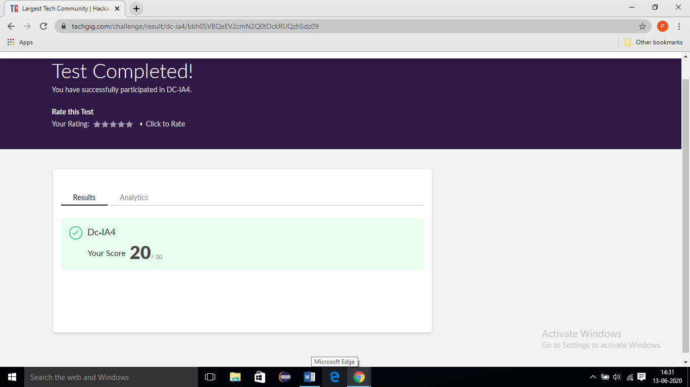

**Online Certification Course Summary:** I have taken my Online Certification Course in **Great learning academy** the course which I have opted is **Introduction to Information Security**. Course contains videos, tutorials, assessments and quiz. Today I have learn about **Intro to Stanford and Computer Security Field** and **Computer Security - Its applications and its future, Innovations in Cybersecurity - Quantum Computing** and **What is the future of cryptography.**

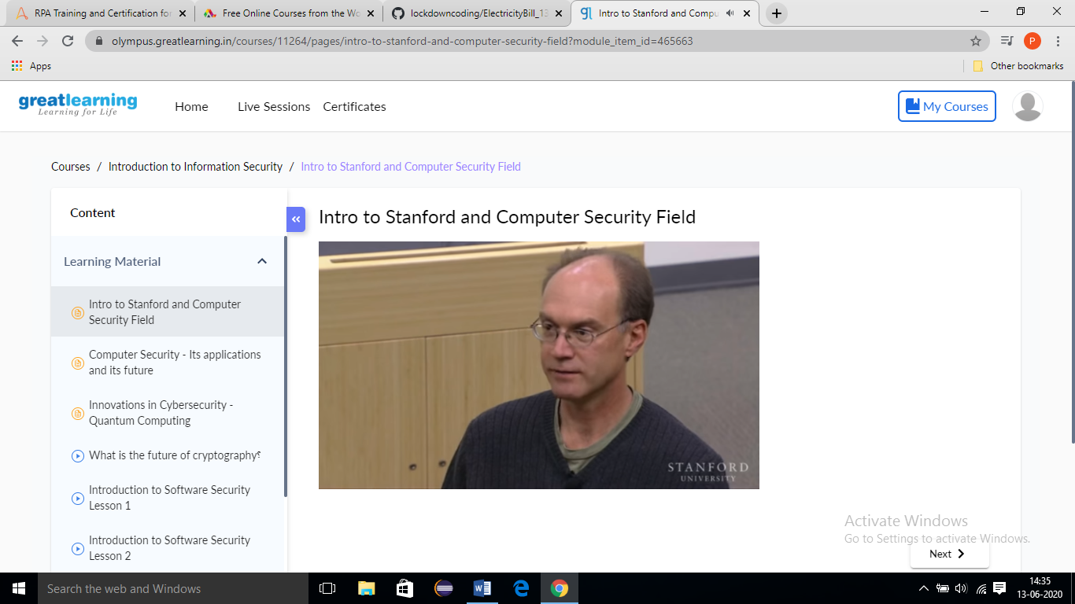

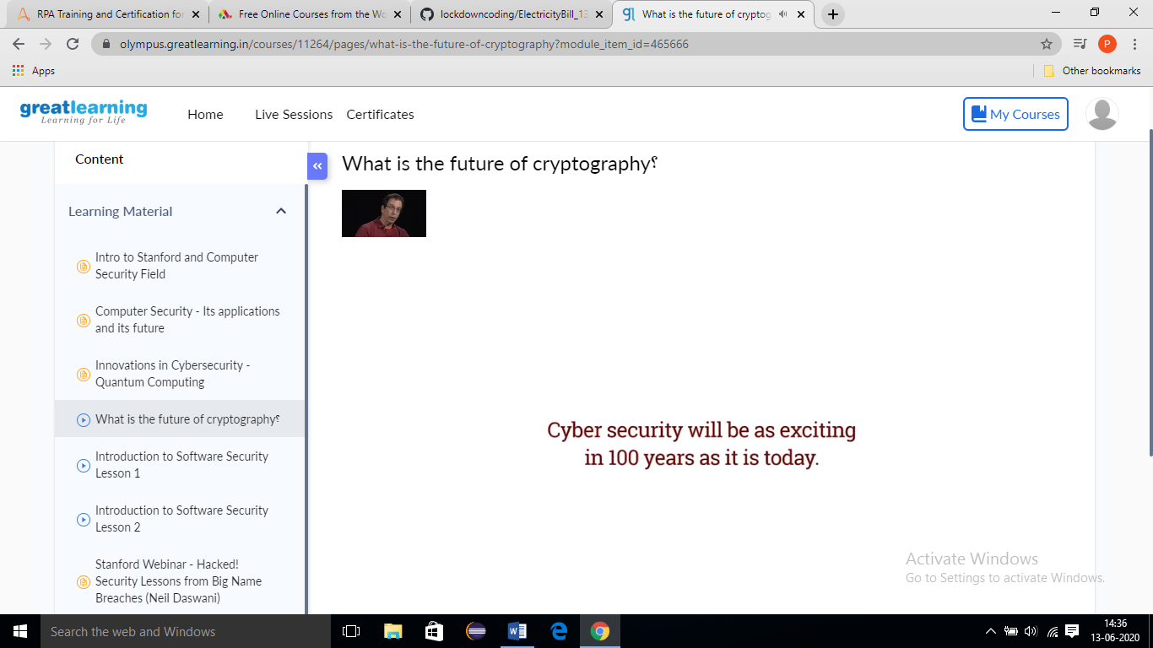

**Online Coding Summary: Today I received one program from Prof. Venkatesh CSE Dept. The program is mentioned above. to my GitHub repository and I’ve shared the snapshot below.**

